Optical thread adapter
3AH6-6 |  | M6
https://www.standa.lt/products/catalog/mounts_accessories?item=15&prod=thread_adapters
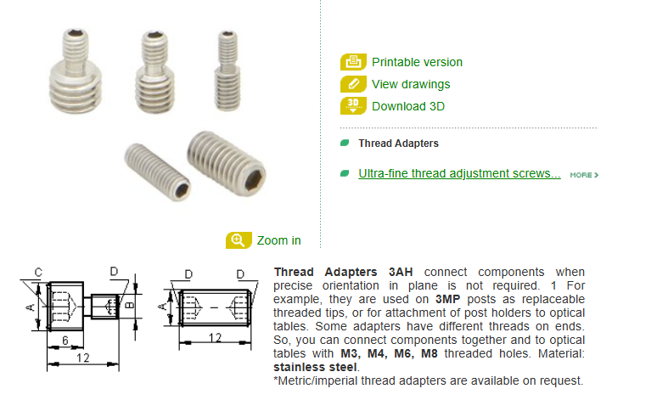

Kinematic Bases
Kinematic Base 6KB
https://www.standa.lt/products/catalog/base_positioners?item=26&prod=kinematic_bases
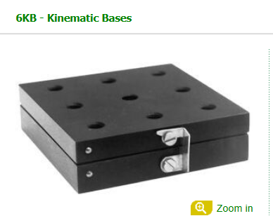
M6 Male to M6 Male, Thread Adapter X5
https://www.edmundoptics.com/f/thread-adapters/13295/
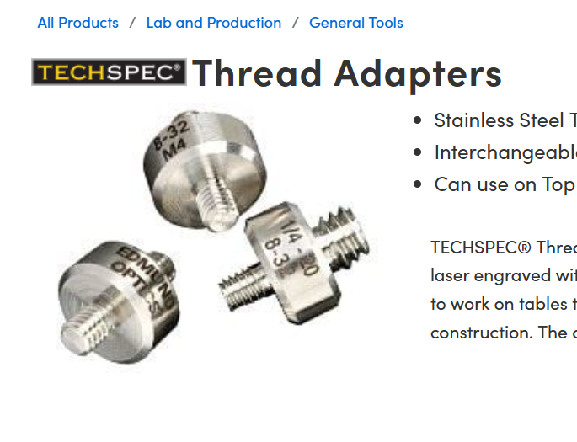
M6 Male to M4 Male, Thread Adapter X 5
M4 Male to M4 Male, Thread Adapter X 5

Threaded Base Plates
English | 85.00 | 50.00

https://www.edmundoptics.com/f/threaded-base-plates/13301/
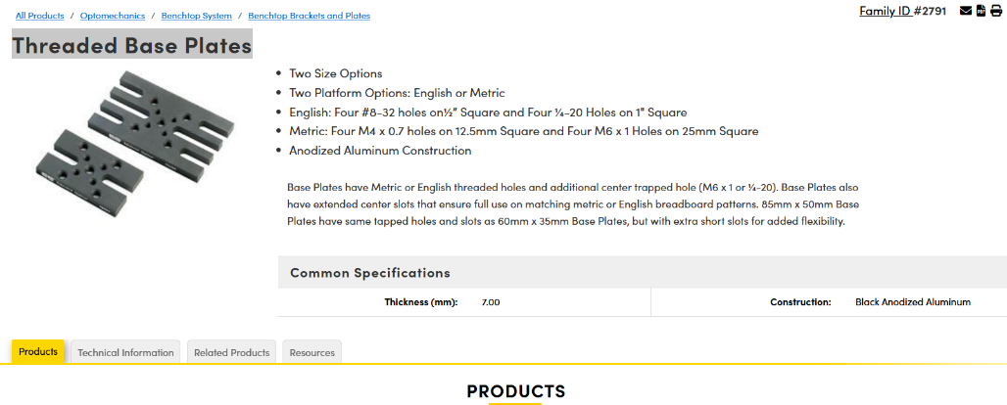

Facom Caliper 150 mm 0.01 mm Resolution Vernier, Metric, Imperial
https://uk.rs-online.com/web/p/calipers/1243554
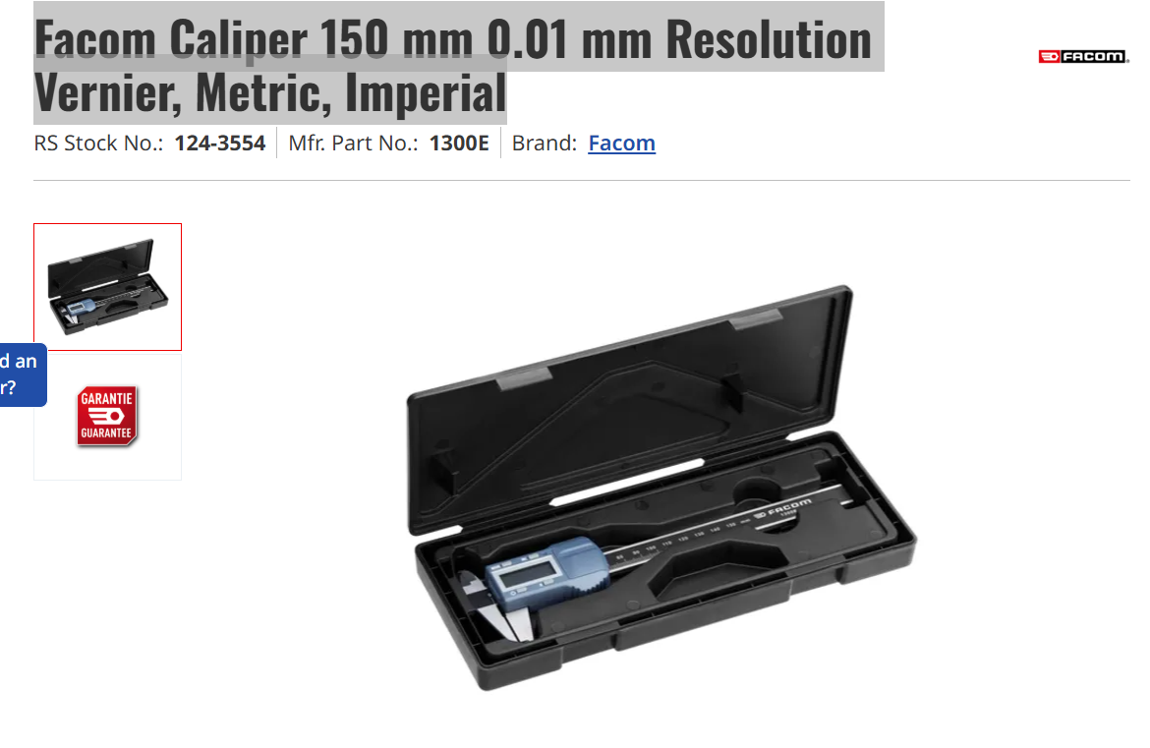

Aluminium Storage box (40x40x40 cm)
https://bagandcase.jp/product/%E3%82%A2%E3%83%AB%E3%83%9F%E3%82%B1%E3%83%BC%E3%82%B9-%E4%B8%AD%E5%9E%8B-%E5%B7%A5%E5%85%B7%E7%AE%B1-%E9%81%93%E5%85%B7%E7%AE%B1-%E3%83%88%E3%83%A9%E3%83%B3%E3%82%AF%E3%82%B1%E3%83%BC%E3%82%B9-%E5%A4%9A%E7%9B%AE%E7%9A%84%E3%83%84%E3%83%BC%E3%83%AB%E3%82%B1%E3%83%BC%E3%82%B9-%E3%83%9E%E3%83%AB%E3%83%81%E3%82%B1%E3%83%BC%E3%82%B9-%E3%83%8F%E3%83%BC%E3%83%89%E3%82%B1%E3%83%BC%E3%82%B9-%E9%8D%B5%E4%BB%98%E3%81%8D-%E8%93%8B%E8%A3%8F%E6%B3%A2%E5%9E%8B%E3%82%B9%E3%83%9D%E3%83%B3%E3%82%B8%E4%BB%98%E3%81%8D-add70/1357/
